Classification of SVM Report Explanation

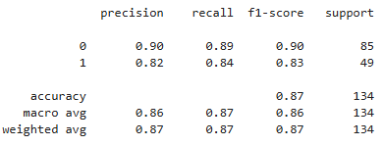

1. Precision:
- Measures how many predicted positives are actually correct
- Formula:
Precision = TP / (TP + FP)
- 0 0.90
- 1 0.82

2. Recall:
- Measures how many actual positives were correctly identified
- Formula:
Recall = TP / (TP + FN)
- 0 0.89
- 1 0.84

3. F1-Score:
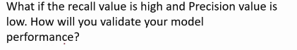

- Harmonic mean of precision and recall
- Best metric when data is imbalanced
- Formula:
F1 = 2 × (Precision × Recall) / (Precision + Recall)
- 0 0.90
- 1 0.83

4. Support:
- Number of actual samples for each class in the test dataset
- 0 85
- 1 49

Accuracy: 0.87:
- The model correctly classifies 87% of all samples
- Accuracy alone is not sufficient for imbalanced datasets, so other metrics are important

Macro Average:
- Precision: 0.82
- Recall: 0.84
- F1-Score: 0.83
- Treats both classes equally, regardless of sample size

Weighted Average:
- Precision: 0.90
- Recall: 0.89
- F1-Score: 0.90
- Takes class imbalance into account (more weight to class 0)

